**PRAKTIKUM PEMROGRAMAN WEB**

**TUGAS #5**



Nama : Yuafiq Alfin Al Khasan

NIM : 23.11.5596

Kelas : IF04

**FAKULTAS ILMU KOMPUTER**

**UNIVERSITAS AMIKOM YOGYAKARTA**

**YOGYAKARTA**

1. Soal 1 Navbar
2. Hasil tampilan

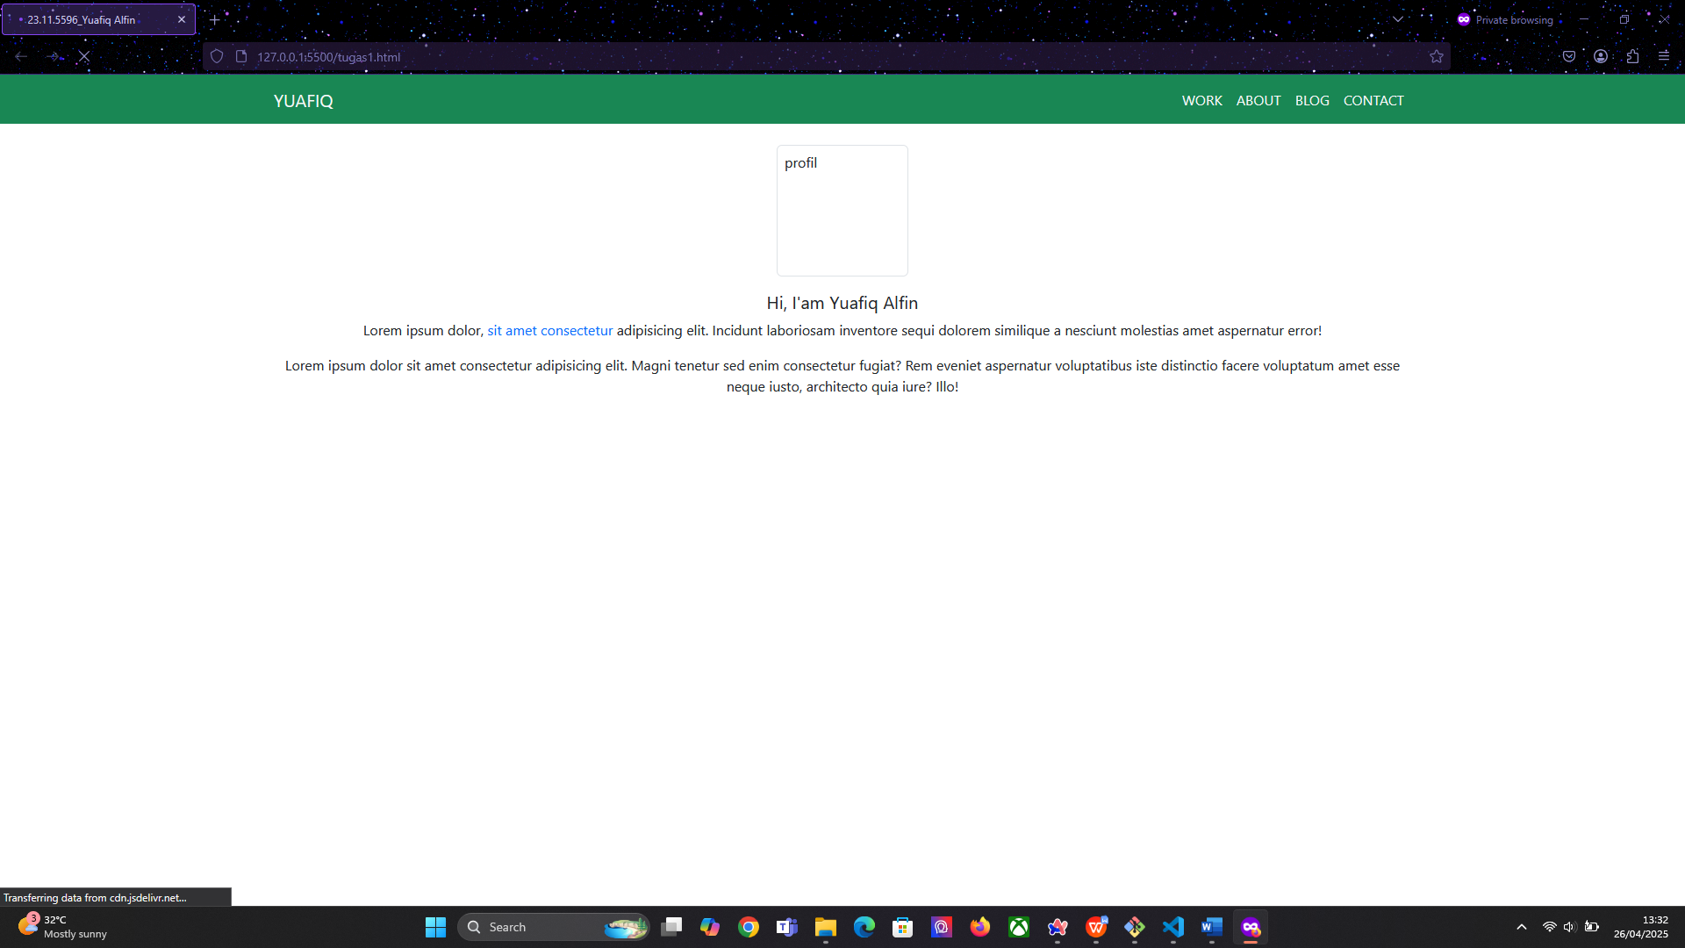

1. Code
2. <!DOCTYPE html>
3. <html lang="en">
4. <head>
5. <meta charset="UTF-8" />
6. <meta name="viewport" content="width=device-width, initial-scale=1.0" />
7. <link
8. href="https://cdn.jsdelivr.net/npm/bootstrap@5.3.5/dist/css/bootstrap.min.css"
9. rel="stylesheet"
10. integrity="sha384-SgOJa3DmI69IUzQ2PVdRZhwQ+dy64/BUtbMJw1MZ8t5HZApcHrRKUc4W0kG879m7"
11. crossorigin="anonymous"
12. />
13. <title>23.11.5596_Yuafiq Alfin</title>
14. </head>
15. <body>
16. <nav class="navbar navbar-expand-sm bg-success">
17. <div class="container">
18. <a class="navbar-brand text-light" href="#">YUAFIQ</a>
19. <div class="justify-content-end" id="navbarNav">
20. <ul class="navbar-nav">
21. <li class="nav-item">
22. <a class="nav-link active text-light" aria-current="page" href="#">WORK</a>
23. </li>
24. <li class="nav-item">
25. <a class="nav-link text-light" href="#">ABOUT</a>
26. </li>
27. <li class="nav-item">
28. <a class="nav-link text-light" href="#">BLOG</a>
29. </li>
30. <li class="nav-item">
31. <a class="nav-link disabled text-light" aria-disabled="true">CONTACT</a>
32. </li>
33. </ul>
34. </div>
35. </div>
36. </nav>
37. <section>
38. <div class="container-md text-center mt-4">
39. <div class="row">
40. <div class="col">
41. <img src="https://via.placeholder.com/150" class="rounded img-thumbnail" height="150px" width="150px" alt="profil"/>
42. </div>
43. </div>
44. <div class="row mt-3">
45. <div class="col">
46. <p class="h5">Hi, I'am Yuafiq Alfin</p>
47. </div>
48. </div>
49. <div class="row">
50. <div class="col">
51. <p>
52. Lorem ipsum dolor, <span class="text-primary">sit amet consectetur</span> adipisicing elit. Incidunt
53. laboriosam inventore sequi dolorem similique a nesciunt molestias
54. amet aspernatur error!
55. </p>
56. </div>
57. </div>
58. <div class="row">
59. <div class="col">
60. <p>
61. Lorem ipsum dolor sit amet consectetur adipisicing elit. Magni
62. tenetur sed enim consectetur fugiat? Rem eveniet aspernatur
63. voluptatibus iste distinctio facere voluptatum amet esse neque
64. iusto, architecto quia iure? Illo!
65. </p>
66. </div>
67. </div>
68. </div>
69. </section>
70. <script
71. src="https://cdn.jsdelivr.net/npm/bootstrap@5.3.5/dist/js/bootstrap.bundle.min.js"
72. integrity="sha384-k6d4wzSIapyDyv1kpU366/PK5hCdSbCRGRCMv+eplOQJWyd1fbcAu9OCUj5zNLiq"
73. crossorigin="anonymous"
74. ></script>
75. <script
76. src="https://cdn.jsdelivr.net/npm/@popperjs/core@2.11.8/dist/umd/popper.min.js"
77. integrity="sha384-I7E8VVD/ismYTF4hNIPjVp/Zjvgyol6VFvRkX/vR+Vc4jQkC+hVqc2pM8ODewa9r"
78. crossorigin="anonymous"
79. ></script>
80. <script
81. src="https://cdn.jsdelivr.net/npm/bootstrap@5.3.5/dist/js/bootstrap.min.js"
82. integrity="sha384-VQqxDN0EQCkWoxt/0vsQvZswzTHUVOImccYmSyhJTp7kGtPed0Qcx8rK9h9YEgx+"
83. crossorigin="anonymous"
84. ></script>
85. </body>
86. </html>

Penjelasan code :

* Code tersebut menggunakan HTML 5 dan menggunakan css Bootstrap 5
* Bagian element <nav> menggunakan class ‘navbar navbar-expand-sm bg-success’ untuk menampilkan navbar berwarna hijau dengan beberapa menu navigasi
* Container utama menggunakan ‘container-md’ agar konten berada ditengah dengan ukuran medium keatas
* Gambar profil menggunakan tag <img> dan menggunakan sumber image dummy
* Teks nama perkenalan singkat menggunakan element paragraph <p> dan kemudian dimanipulasi menggunakan bootstrap menjadi h5
* Dua paragraph dibawahnya menggunakan element <p> dan ada salah satu bagian menggunakan class ‘text primary’ untuk membuatnya menjadi warna biru

1. Soal 2 Footer
2. Hasil tampilan

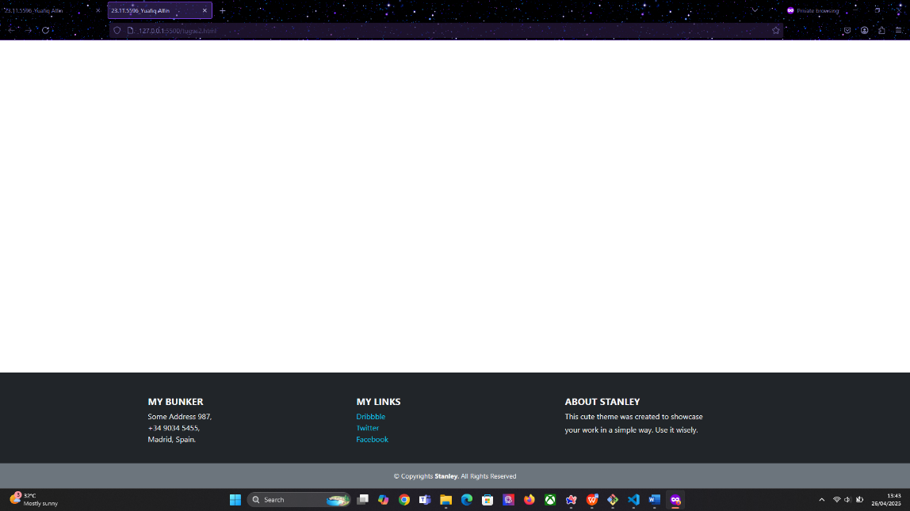

1. Code
2. <!DOCTYPE html>
3. <html lang="en">
4. <head>
5. <meta charset="UTF-8" />
6. <meta name="viewport" content="width=device-width, initial-scale=1" />
7. <link
8. href="https://cdn.jsdelivr.net/npm/bootstrap@5.3.2/dist/css/bootstrap.min.css"
9. rel="stylesheet"
10. />
11. <title>23.11.5596_Yuafiq Alfin</title>
12. </head>
13. <body class="min-vh-100">
14. <footer class="bg-dark text-light pt-5 fixed-bottom">
15. <div class="container">
16. <div class="row text-center text-md-start">
17. <div class="col-md-4 mb-4">
18. <h5 class="fw-bold">MY BUNKER</h5>
19. <ul class="list-unstyled">
20. <li>Some Address 987,</li>
21. <li>+34 9034 5455,</li>
22. <li>Madrid, Spain.</li>
23. </ul>
24. </div>
25. <div class="col-md-4 mb-4">
26. <h5 class="fw-bold">MY LINKS</h5>
27. <ul class="list-unstyled">
28. <li>
29. <a href="#" class="text-info text-decoration-none">Dribbble</a>
30. </li>
31. <li>
32. <a href="#" class="text-info text-decoration-none">Twitter</a>
33. </li>
34. <li>
35. <a href="#" class="text-info text-decoration-none">Facebook</a>
36. </li>
37. </ul>
38. </div>
39. <div class="col-md-4 mb-4">
40. <h5 class="fw-bold">ABOUT STANLEY</h5>
41. <p class="mb-1">This cute theme was created to showcase</p>
42. <p>your work in a simple way. Use it wisely.</p>
43. </div>
44. </div>
45. </div>
46. <div class="bg-secondary text-center py-3">
47. <div class="container">
48. <p class="mb-0 small">
49. &copy; Copyrights <strong>Stanley</strong>. All Rights Reserved
50. </p>
51. </div>
52. </div>
53. </footer>
54. <script
55. src="https://cdn.jsdelivr.net/npm/bootstrap@5.3.5/dist/js/bootstrap.bundle.min.js"
56. integrity="sha384-k6d4wzSIapyDyv1kpU366/PK5hCdSbCRGRCMv+eplOQJWyd1fbcAu9OCUj5zNLiq"
57. crossorigin="anonymous"
58. ></script>
59. <script
60. src="https://cdn.jsdelivr.net/npm/@popperjs/core@2.11.8/dist/umd/popper.min.js"
61. integrity="sha384-I7E8VVD/ismYTF4hNIPjVp/Zjvgyol6VFvRkX/vR+Vc4jQkC+hVqc2pM8ODewa9r"
62. crossorigin="anonymous"
63. ></script>
64. <script
65. src="https://cdn.jsdelivr.net/npm/bootstrap@5.3.5/dist/js/bootstrap.min.js"
66. integrity="sha384-VQqxDN0EQCkWoxt/0vsQvZswzTHUVOImccYmSyhJTp7kGtPed0Qcx8rK9h9YEgx+"
67. crossorigin="anonymous"
68. ></script>
69. </body>
70. </html>

Penjelasan code :

* Code tersebut menggunakan HTML 5 dan menggunakan css Bootstrap 5
* Pada element <body> diatas menggunakan class ‘min-vh-100’ untuk membuat tinggi minimum halaman mencakup seluruh layer
* Element footer menggunakan class ‘fixed-bottom’ agar selalu berada dibagian bawah viewport dan menggunakan background ‘bg-dark’ dengan teks putih ‘text-light’
* Isi element <footer> terdiri dari 3 kolom yang tersusun responsive
* Kolom pertama menampilkan beberapa informasi menggunakan unordered list disusun tanpa bullet ‘list-unstyled’
* Kolom kedua berisi link ke beberapa platform seperti twitter, facebook, dll.
* Kolom Ketiga berisi tentang informasi. Menggunakan judul bold ‘fw-bold’ dan dibawahnya terdapat teks dengan menggunakan element <p>
* Bagian baris bawah menampilkan teks hak cipta dengan background gelap ‘bg-secondary’ dengan nama ‘Stanley’ menggunakan tag <strong> agar terlihat lebih tebal

1. Soal 2 Navbar, Body, Footer
2. Hasil tampilan

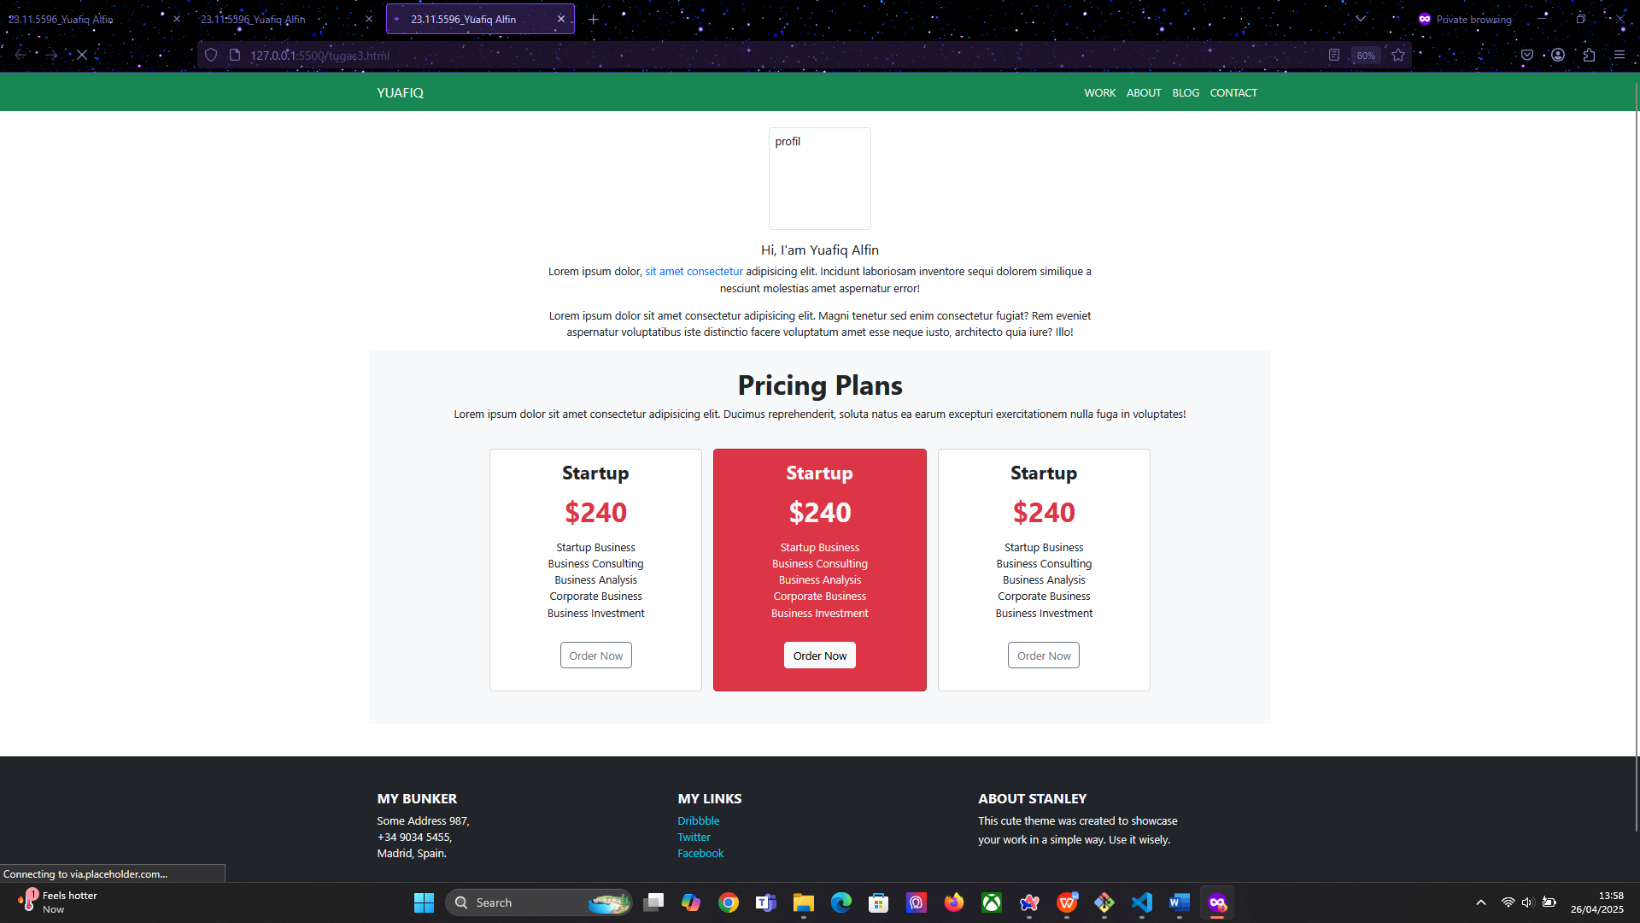

1. Code
2. <!DOCTYPE html>
3. <html lang="en">
4. <head>
5. <meta charset="UTF-8" />
6. <meta name="viewport" content="width=device-width, initial-scale=1.0" />
7. <link
8. href="https://cdn.jsdelivr.net/npm/bootstrap@5.3.5/dist/css/bootstrap.min.css"
9. rel="stylesheet"
10. integrity="sha384-SgOJa3DmI69IUzQ2PVdRZhwQ+dy64/BUtbMJw1MZ8t5HZApcHrRKUc4W0kG879m7"
11. crossorigin="anonymous"
12. />
13. <title>23.11.5596_Yuafiq Alfin</title>
14. </head>
15. <body>
16. <nav class="navbar navbar-expand-sm bg-success">
17. <div class="container">
18. <a class="navbar-brand text-light" href="#">YUAFIQ</a>
19. <div class="justify-content-end" id="navbarNav">
20. <ul class="navbar-nav">
21. <li class="nav-item">
22. <a class="nav-link active text-light" aria-current="page" href="#"
23. >WORK</a
24. >
25. </li>
26. <li class="nav-item">
27. <a class="nav-link text-light" href="#">ABOUT</a>
28. </li>
29. <li class="nav-item">
30. <a class="nav-link text-light" href="#">BLOG</a>
31. </li>
32. <li class="nav-item">
33. <a class="nav-link disabled text-light" aria-disabled="true"
34. >CONTACT</a
35. >
36. </li>
37. </ul>
38. </div>
39. </div>
40. </nav>
41. <section>
42. <div class="container-md text-center mt-4">
43. <div class="row">
44. <div class="col">
45. <img
46. src="https://via.placeholder.com/150"
47. class="rounded img-thumbnail"
48. height="150px"
49. width="150px"
50. alt="profil"
51. />
52. </div>
53. </div>
54. <div class="row mt-3">
55. <div class="col">
56. <p class="h5">Hi, I'am Yuafiq Alfin</p>
57. </div>
58. </div>
59. <div class="row justify-content-center">
60. <div class="col-8">
61. <p>
62. Lorem ipsum dolor,
63. <span class="text-primary">sit amet consectetur</span> adipisicing
64. elit. Incidunt laboriosam inventore sequi dolorem similique a
65. nesciunt molestias amet aspernatur error!
66. </p>
67. </div>
68. </div>
69. <div class="row justify-content-center">
70. <div class="col-8">
71. <p>
72. Lorem ipsum dolor sit amet consectetur adipisicing elit. Magni
73. tenetur sed enim consectetur fugiat? Rem eveniet aspernatur
74. voluptatibus iste distinctio facere voluptatum amet esse neque
75. iusto, architecto quia iure? Illo!
76. </p>
77. </div>
78. </div>
79. </div>
80. </section>
81. <section>
82. <div class="container-md bg-light px-5 pb-5">
83. <div class="py-4 text-center">
84. <p class="h1 fw-bold">Pricing Plans</p>
85. <p class="text-center">
86. Lorem ipsum dolor sit amet consectetur adipisicing elit. Ducimus
87. reprehenderit, soluta natus ea earum excepturi exercitationem nulla
88. fuga in voluptates!
89. </p>
90. </div>
91. <div class="row justify-content-center">
92. <div class="card col-md-3 pb-2 text-center">
93. <div class="card-body">
94. <div class="card-title h3 fw-bold">Startup</div>
95. <div class="card-title h1 fw-bold text-danger my-3">$240</div>
96. <ul class="list-unstyled mb-4">
97. <li>Startup Business</li>
98. <li>Business Consulting</li>
99. <li>Business Analysis</li>
100. <li>Corporate Business</li>
101. <li>Business Investment</li>
102. </ul>
103. <div class="card-text">
104. <button type="button" class="btn btn-outline-secondary my-2">
105. Order Now
106. </button>
107. </div>
108. </div>
109. </div>
110. <div class="card col-md-3 pb-2 text-center bg-danger mx-3">
111. <div class="card-body">
112. <div class="card-title h3 fw-bold text-light">Startup</div>
113. <div class="card-title h1 fw-bold text-danger my-3 text-light">$240</div>
114. <ul class="list-unstyled mb-4">
115. <li class="text-light">Startup Business</li>
116. <li class="text-light">Business Consulting</li>
117. <li class="text-light">Business Analysis</li>
118. <li class="text-light">Corporate Business</li>
119. <li class="text-light">Business Investment</li>
120. </ul>
121. <div class="card-text">
122. <button type="button" class="btn btn-light my-2">
123. Order Now
124. </button>
125. </div>
126. </div>
127. </div>
128. <div class="card col-md-3 pb-2 text-center">
129. <div class="card-body">
130. <div class="card-title h3 fw-bold">Startup</div>
131. <div class="card-title h1 fw-bold text-danger my-3">$240</div>
132. <ul class="list-unstyled mb-4">
133. <li>Startup Business</li>
134. <li>Business Consulting</li>
135. <li>Business Analysis</li>
136. <li>Corporate Business</li>
137. <li>Business Investment</li>
138. </ul>
139. <div class="card-text">
140. <button type="button" class="btn btn-outline-secondary my-2">
141. Order Now
142. </button>
143. </div>
144. </div>
145. </div>
146. </div>
147. </div>
148. </section>
149. <footer class="bg-dark text-light pt-5 mt-5">
150. <div class="container">
151. <div class="row text-center text-md-start">
152. <div class="col-md-4 mb-4">
153. <h5 class="fw-bold">MY BUNKER</h5>
154. <ul class="list-unstyled">
155. <li>Some Address 987,</li>
156. <li>+34 9034 5455,</li>
157. <li>Madrid, Spain.</li>
158. </ul>
159. </div>
160. <div class="col-md-4 mb-4">
161. <h5 class="fw-bold">MY LINKS</h5>
162. <ul class="list-unstyled">
163. <li>
164. <a href="#" class="text-info text-decoration-none">Dribbble</a>
165. </li>
166. <li>
167. <a href="#" class="text-info text-decoration-none">Twitter</a>
168. </li>
169. <li>
170. <a href="#" class="text-info text-decoration-none">Facebook</a>
171. </li>
172. </ul>
173. </div>
174. <div class="col-md-4 mb-4">
175. <h5 class="fw-bold">ABOUT STANLEY</h5>
176. <p class="mb-1">This cute theme was created to showcase</p>
177. <p>your work in a simple way. Use it wisely.</p>
178. </div>
179. </div>
180. </div>
181. <div class="bg-secondary text-center py-3">
182. <div class="container">
183. <p class="mb-0 small">
184. &copy; Copyrights <strong>Stanley</strong>. All Rights Reserved
185. </p>
186. </div>
187. </div>
188. </footer>
189. <script
190. src="https://cdn.jsdelivr.net/npm/bootstrap@5.3.5/dist/js/bootstrap.bundle.min.js"
191. integrity="sha384-k6d4wzSIapyDyv1kpU366/PK5hCdSbCRGRCMv+eplOQJWyd1fbcAu9OCUj5zNLiq"
192. crossorigin="anonymous"
193. ></script>
194. <script
195. src="https://cdn.jsdelivr.net/npm/@popperjs/core@2.11.8/dist/umd/popper.min.js"
196. integrity="sha384-I7E8VVD/ismYTF4hNIPjVp/Zjvgyol6VFvRkX/vR+Vc4jQkC+hVqc2pM8ODewa9r"
197. crossorigin="anonymous"
198. ></script>
199. <script
200. src="https://cdn.jsdelivr.net/npm/bootstrap@5.3.5/dist/js/bootstrap.min.js"
201. integrity="sha384-VQqxDN0EQCkWoxt/0vsQvZswzTHUVOImccYmSyhJTp7kGtPed0Qcx8rK9h9YEgx+"
202. crossorigin="anonymous"
203. ></script>
204. </body>
205. </html>

Penjelasan Code :

* Code tersebut menggunakan HTML 5 dan menggunakan css Bootstrap 5
* Element <nav> diatas menggunakan code dari tugas nomor 1 sebelumnya
* Tampilan card tersebut dibungkus dalam element <section>
* Container tersebut menggunakan class ‘container-md’ untuk container ukuran menengah keatas dan menggunakan background terang ‘bg-light’ serta padding x ‘px-5’ untuk padding horizontal dan padding bottom ‘pb-5’
* Bagian atas berisi judul “pricing plans” dengan class ‘h1 text-center py-4’
* Pembungkus kartu dibungkus menggunakan element <div> dengan class ‘row justify-content-center’ untuk Menyusun ketiga kartu secara sejajar di tengah layer
* Card pertama dan ketiga memiliki tampilan yang sama dengan latar puth
* Card kedua menggunakan background merah ‘bg-danger’ dan menggunakan text berwarna putih ‘text-light’
* Card diatas menggunakan class ‘card, card body, card title’ dalam pembuatanya
* Masing masing card memiliki List fitur didalam card dibuat dengan unordered list dan menggunakan class ‘list-unstyled’ agar tidak muncul bulled point
* Masing masing card memiliki tombol “order Now” sebagai call to action. Card satu dan tiga menggunakan desain tombol ‘btn-outline-secondary’ sedangkan card dua menggunakan desain tombol ‘btn-light’
* Element <footer> diatas menggunakan code dari tugas nomor 2 sebelumnya